IGC VEGETABLE GROUP MEETING - 16th MARCH 2026
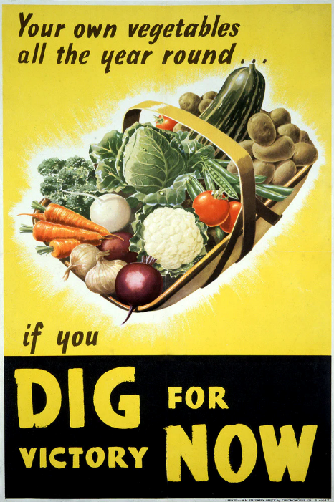
Looking at world events, Peter commented that soon it is quite likely that there will be shortages of vegetables and fruit in shops in addition to an increase in costs, because of oil and gas supply problems. We are probably not in ‘Dig for Victory’ territory, but it would be good to be prepared and encourage members to grow more vegetables!
OVER WINTER ISSUES:
- Joy had planted her peas and broad beans in November and they are doing very well. The Cavolo Nero and leeks just keep on going!
- Clare has rhubarb sprouting and kale, Swiss chard, garlic and leeks are all doing well. She was concerned that her stored apples were not keeping well and was looking for suggestions.
- Paul reported that his garlic and chard are good, asparagus is starting as are the rhubarb, herbs, currants and vine is in bud. Brussels failed, but the radish and lettuce grown in the north facing raised bed are doing very well.
- Kathy and Pauline had not planted during last autumn.
- Stephen and Rosemary were pleased that the lettuce had survived the frost. They are growing mustard as a green manure for the first time. Chard has been harvested throughout the winter and raspberries and currant bushes were replaced with blueberries, which are doing well.
- Alison has successfully grown garlic and leeks through the winter and has recently planted onions, peas, chillies, strawberries, beetroot, and potatoes. Worryingly, only one courgette has germinated so far!
- Carelle’s Cavallo Nero has been devastated by caterpillars. Leeks, beetroot and herbs are all doing well and raspberry plants are still available by appointment. Asparagus plants are being invaded by raspberries!
- Ian has recently bought some variegated leaf tomato plants which he is looking forward to growing.
- Afke is sharing a communal garden in her new property, so is hoping to start planting this year.
- Caz is thrilled that her first excursion into vegetable growing has been so successful with radishes in a window box.
- Peter was delighted that the Batavia lettuce planted last October has been so successful and is still producing leaves. About 50% of the broad beans planted out last November were lost and a row of carrots planted last April, finally germinated at the end of September and were harvested up to the end of January.

GROWING PLANS FOR THE YEAR.
- Caz wants to grow asparagus and is researching the availability of crowns.
- Joy is growing yellow and red onions for the first time around along with many varieties of tomatoes, courgettes, and summer salads.
- Di and Ken have grown salad crops previously, but they had a problem with a fungus which developed in their leeks, infecting the soil. They are considering doing a dig and no dig experiment for vegetables this year.
- Cathy is still looking and learning, but she’s planning to grow herbs and salad crops.
- Pauline is a confirmed no dig gardener and already has three beds ready for planting vegetables.
- Clare will be starting to plant on her return from holiday.
- Jan and Paul have terrible clay soil and so have started raised beds. They use seed trays under lamps to aid germination and will be growing blueberries, raspberries, salads, tomatoes, butternut, peppers, and cucumbers.
- Rosemary and Stephen - nothing planted yet, but will they will be growing chillies. They prefer to plant seeds in pots rather than trays.
- Carelle intends to grow, butternut, courgette, tomatoes – probably fewer varieties than last year - beetroot, leeks, Cavallo Nero, Padrón peppers and fruits.
- Ian is planning on growing butternuts as he believes they are good for treatment of canine atmospheric turbulence. Afke does not have any specific plans, but she is willing to help others.
GARDEN IDEAS AND PURCHASES
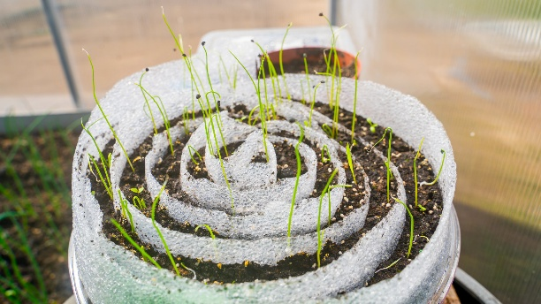
- Ian has discovered a Perlite/Vermiculite product being sold in Bricomarché as insulation. At 27€ a bag it is good value and excellent for mixing with compost for seedlings.
- Pool filtration grit is a good replacement for horticultural grit at 5€ for a 35kg bag.
- Alison told us about the new Swiss roll method of seed planting which Mel Chappell had been describing.
Very effective, saves space and enables better seedling root growth. More details can be found on YouTube under Seed Snails.
SEED ‘SNAILS’
- Jan is growing blackberries over an archway, which makes picking easier.
- Clare has an obelisk made from cycle parts.
- Pauline recommended using pallets pitched together to grow cucumbers and squashes over.
- Carolyn recommended painting walls white to attract light into a dark corner.
- Afke recommended a book freely available from Gamm Vert, giving month by month advice on vegetable growing. She also mentioned that pallets are free at Leclerc.
FUTURE TOPICS
Several members have mentioned the problems they’ve had growing brassicas in the area. It was suggested that this should be a topic for more in-depth discussion in the future.
OPEN GARDENS 2026
Stephen and Rosemary and Ian are opening their gardens in mid June as part of the Open Gardens scheme.

